Global Reports on Women in Engineering Compilation
References
Report | Cover
2020. The State of US Science & Engineering National Science Board. 2020. Science and Engineering Indicators Reports for US.  https://ncses.nsf.gov/indicators/reports  https://ncses.nsf.gov/indicators  Indicators provides information on the state of the U.S. (and global) science and engineering (S&E) enterprise over time and within a global context. Indicators is a factual and policy-neutral source of high-quality U.S. and international data; it does not offer policy options or make policy recommendations. The indicators presented in the report are quantitative representations relevant to the scope, quality, and vitality of the S&E enterprise. | 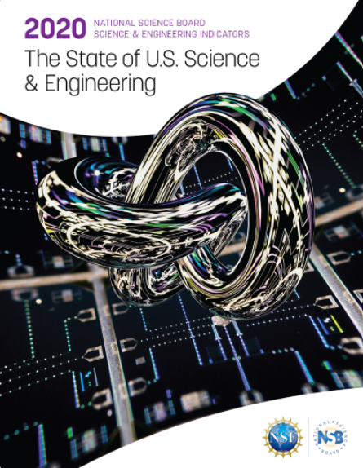
2020  Global Engineering Capability Review, Royal Academy of Engineering (UK)  https://www.raeng.org.uk/publications/reports/global-engineering-capability-review  Prepared by the Economist Intelligence Unit, this report measures the abilities of 99 countries to conduct key engineering activities in a safe and innovative way. | 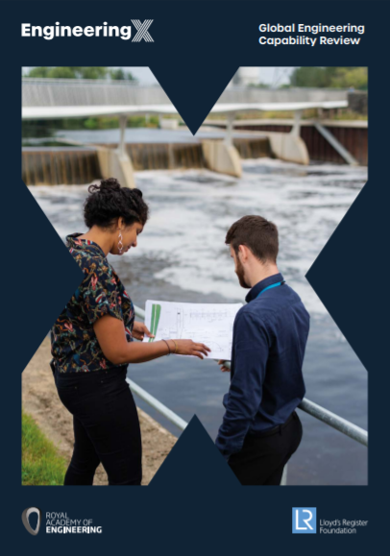
2020 Annual SWE (Society of Women Engineers) Report and Literature Review  https://research.swe.org/wp-content/uploads/sites/2/2020/03/FINAL_SWESOW2020-links-1.pdf  SWE’s assessment of the most significant research found in the past year’s social science literature on women engineers and women in STEM disciplines, plus recommendations for future analysis and study. | 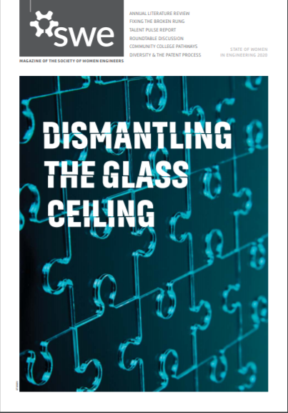
2020  Mind the 100 Year Gap. The Global Gender Gap Report 2020 published by the World Economic Forum  https://www.weforum.org/reports/gender-gap-2020-report-100-years-pay-equality  Gender parity has a fundamental bearing on whether or not economies and societies thrive. Developing and deploying one-half of the world’s available talent has a huge bearing on the growth, competitiveness and future-readiness of economies and businesses worldwide.  The index’s rankings offer an effective means to benchmark progress. They are designed to create global awareness of the challenges that gender gaps pose, as well as the opportunities that emerge when action is taken to reduce them. | 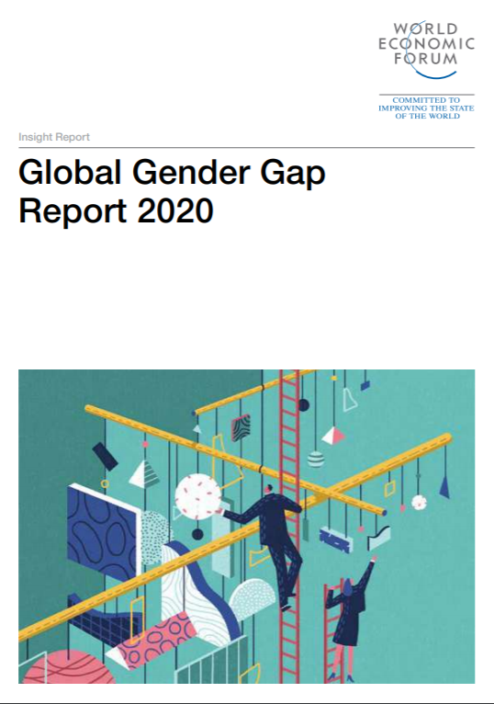
- 2019  - INCOSE Journal Insight (special edition on diversity in engineering) published October 2019 https://onlinelibrary.wiley.com/doi/full/10.1002/inst.12252  Gender diversity in Systems Engineering report with global statistics.  - This inaugural special edition on ‘Diversity in Systems Engineering’ explores the role of the systems engineering community in embracing diversity, equity, and inclusion as key enablers in the systems approach. As master integrators, systems engineers are accountable for delivering optimal affordable system solutions to complex problems. To do so requires more than an understanding of technology. It requires an understanding of people and social systems ‐ culture and the impact of cultural barriers, the cost of gender inequity, the need for cognitive and idea diversity, and a path to achieve inclusivity by design to name just a few areas. These represent a sample of the topics addressed in this special edition, where authors share their past experiences and forward thinking on the role of diversity, equity, and inclusion in developing systems and global systems engineering leadership. | 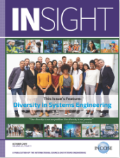
- 2019  UNESCO Institute of Statistics (UIS) Data Fact sheets http://uis.unesco.org/sites/default/files/documents/fs55-women-in-science-2019-en.pdf  - http://uis.unesco.org/en#slideoutmenu  - Also blog here  - http://uis.unesco.org/en/blog/where-are-all-women-science-and-research | 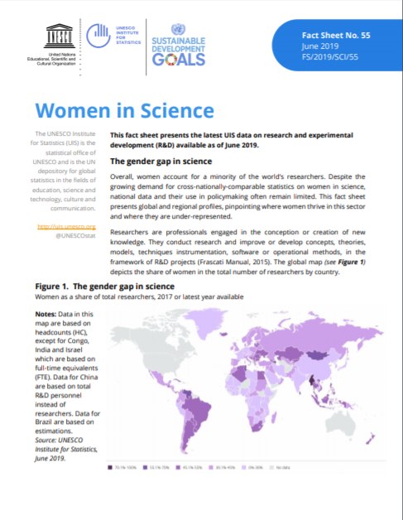
2019  IESF Data on engineering in France  https://www.iesf.fr/offres/doc_inline_src/752/IESF-ENQUETE2019-Resume.pdf  French compilation state of engineering report showing disaggregated data for women engineers in France only.  Full report here  https://www.iesf.fr/offres/doc_inline_src/752/ENQUETE_IESF_2017_Version_associations.pdf | 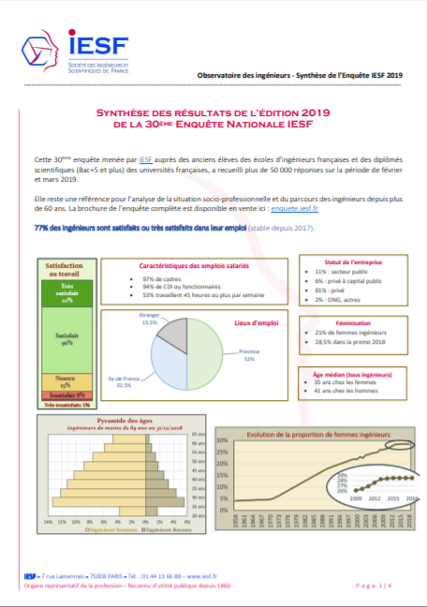
2019  OECD Data https://www.oecd.org/gender/data/why-dont-more-girls-choose-stem-careers.htm  https://www.oecd-ilibrary.org/docserver/02bd2b68-en.pdf?expires=1586874412&id=id&accname=guest&checksum=1E7612EC7C9663D6B63FA84297DBC546  - « Why don’t more girls choose to pursue a science career? », PISA in Focus, n° 93, OECD Publishing, Paris, https://doi.org/10.1787/02bd2b68-en  - Stoet, G. and D.C. Geary (2018), “The Gender-Equality Paradox in Science, Technology, Engineering, and Mathematics Education”, Psychological Science, 29/4, 581–593. https://doi.org/10.1177/0956797617741719  - OECD (2018), "Indicator B5 Who is expected to graduate from tertiary education?", in Education at a Glance 2018: OECD Indicators, OECD Publishing, Paris, https://doi.org/10.1787/eag-2018-18-en | 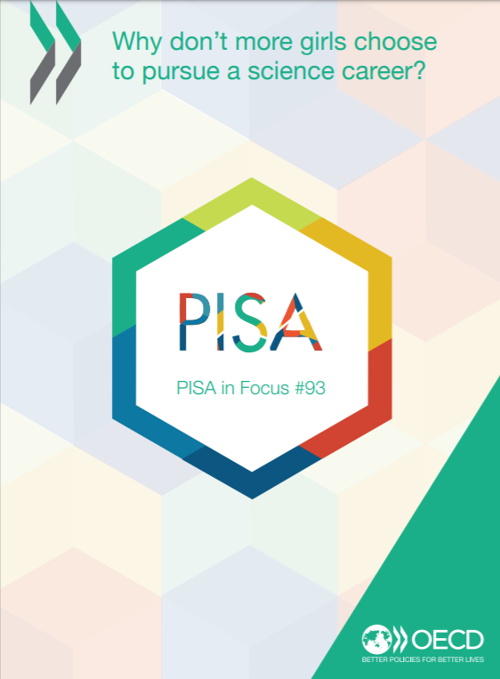
2018  She Figures Report, European Commission  https://op.europa.eu/en/publication-detail/-/publication/9540ffa1-4478-11e9-a8ed-01aa75ed71a1/language-en  The ‘She figures’ publication provides a range of indicators on gender equality in research and innovation at pan-European level. It aims to give an overview of the gender equality situation, using a wide range of indicators to examine the impact and effectiveness of policies implemented in this area.  Also file:///C:/Users/dawnb/Downloads/KI0418554ENN.en.pdf (published 2019) | 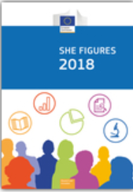
2018  International Labour Organisation Data https://www.ilo.org/asia/publications/WCMS_645601/lang--en/index.htm  Game changers: Women and the future of work in Asia and the Pacific  The report examines the situation of women in the region and analyses progress and obstacles in terms of gender equality in the world of work. | 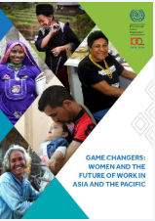
2018  Eurostat database  Professions still split along gender lines  https://ec.europa.eu/eurostat/en/web/products-eurostat-news/-/EDN-20180307-1  Female students enrolled in engineering study data (2012 is latest data available)  https://appsso.eurostat.ec.europa.eu/nui/submitViewTableAction.do | 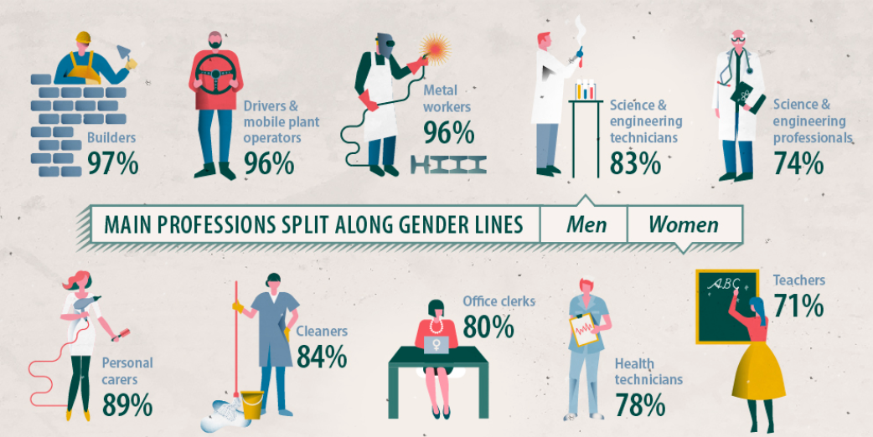
- 2017  - OECD (2017), Education at a Glance 2017: OECD Indicators, OECD Publishing, Paris. http://dx.doi.org/10.1787/eag-2017-en  Education at a Glance: OECD Indicators is the authoritative source for information on the state of education around the world. With more than 125 charts and 145 tables included in the publication and much more data available on the educational database, Education at a Glance 2017 provides key information on the output of educational institutions; the impact of learning across countries; the financial and human resources invested in education; access, participation and progression in education; and the learning environment and organisation of schools. | 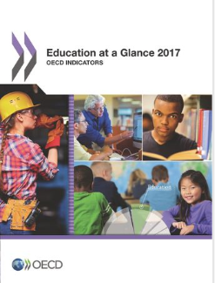
- 2017  - UNESCO. 2017. Cracking the code: Girls’ and women’s education in science technology, engineering and mathematics (STEM). Paris: UNESCO Publishing. Retrieved from: https://unesdoc.unesco.org/ark:/48223/pf0000253479.  Girls' and women's education in science, technology, engineering and mathematics (STEM) | 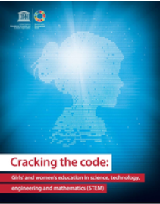
- 2017  - African catalyst project: Statistical data for women in science and engineering. A pilot project of Nigeria, Rwanda and Malawi. Paris: World Federation of Engineering Organizations. Agberagba, V. 2017. Retrieved from: https://afbe.org.uk/docs/African%20catalyst%20Project%20%20-%20final%20%20%20submission%20(1).pdf | 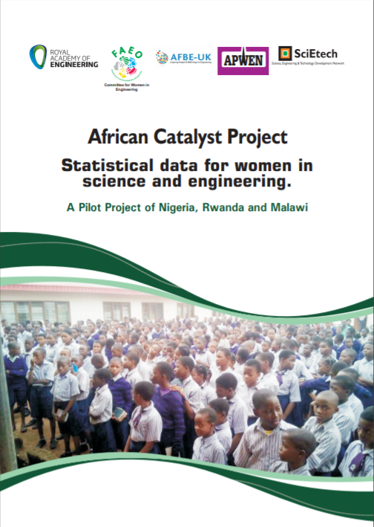
- 2016  - Royal Academy of Engineering Report 2016 Engineering and economic growth: a global view https://www.raeng.org.uk/publications/reports/engineering-and-economic-growth-a-global-view  - This report, by the Centre for Economics and Business Research (Cebr) commissioned by the Royal Academy of Engineering, considers the impact of engineering on economic development on a global scale. For the first time, this report brings together all available data from 99 countries (see Annex A for a full list) to paint a picture of global engineering: its workforce, output, prospective recruits, the quality of research and where its impacts are most needed. It uses a comprehensive selection of indicators to calculate a new ‘Engineering Index’: a measure of the engineering strength of different countries. | 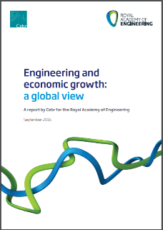
- 2016  WIE WFEO Presentation of Engineering Strategic Indicators, Lima  - Eng. Ania Lopez – Consiglio Nazionale degli Ingegneri, Italy  - (not online) | 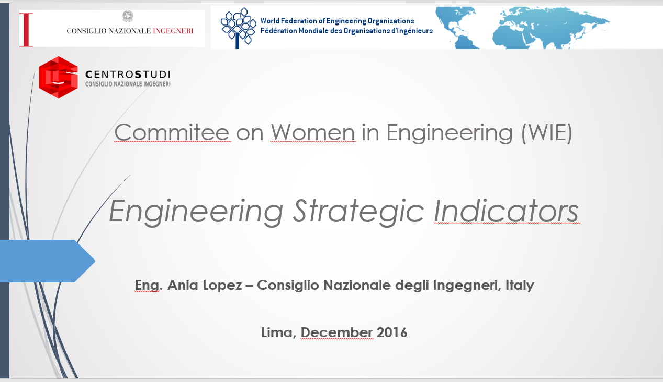

2016
Women in STEM Disciplines: The Yfactor 2016 Global Report on Gender in Science, Technology, Engineering and Mathematics
- This book presents the findings of a survey that analyzes a unique set of data on gender studies departments, and provides a clear and simple synthesis of heterogeneous databases on the gender gap in the STEM (Science, Technology, Engineering and Mathematics) setting, helping readers understand key trends and developments.
2016  STEM and Gender Advancement, SAGA: Measuring Gender Equality in Science and Engineering http://uis.unesco.org/sites/default/files/documents/saga-sti-objectives-list-wp1-2016-en.pdf  SAGA is a global UNESCO project supported by the Government of Sweden through the Swedish International Development Cooperation Agency (Sida). The general objective of SAGA is to contribute to reducing the gender gap in science, technology, engineering and mathematics (STEM) fields in all countries at all levels of education and research, by determining, measuring and assessing sex-disaggregated data, as well as supporting the design and implementation of policy instruments that affect gender equality in STEM. Furthermore, SAGA aims to analyze how policies affect the gender balance in STEM, undertake inventories of science, technology and innovation (STI) gender equality policies, develop new and better indicators to provide tools for evidence-based policy-making, build capacity in Member States for data collection on gender in STEM, and prepare methodological documents to support the collection of statistics. | 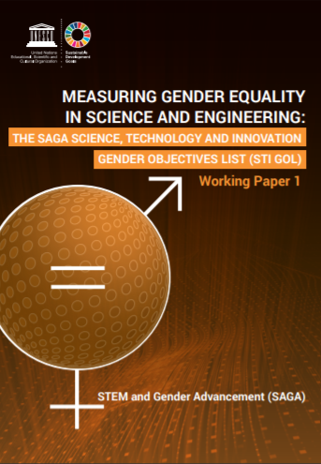
2015  UNESCO Science Report: Towards 2030  https://unesdoc.unesco.org/ark:/48223/pf0000235407  For two decades now, the UNESCO Science Report series has been mapping science, technology and innovation (STI) around the world on a regular basis. Since STI do not evolve in a vacuum, this latest edition summarizes the evolution since 2010 against the backdrop of socio-economic, geopolitical and environmental trends that have helped to shape contemporary STI policy and governan | 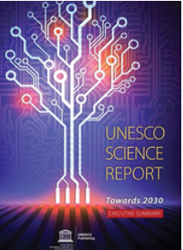

2015
YFactor Report

Women in STEM Disciplines report 2015
Building on the methodology and experience, the survey is now global. In partnership with OECD, and UNESCO, as well as the support of nearly 40 NGO’ working on women in science and technology from Middle East and North Africa, Asia, Latin America, North America, Europe and Canada this survey is now covering all regions in the world. The goal remains the same: assess evolutions, analyze key issues and identify solutions.

2010  Why So Few? US report  https://www.researchgate.net/publication/234647120_Why_So_Few_Women_in_Science_Technology_Engineering_and_Mathematics  The number of women in science and engineering is growing, yet men continue to outnumber women, especially at the upper levels of these professions. In elementary, middle, and high school, girls and boys take math and science courses in roughly equal numbers, and about as many girls as boys leave high school prepared to pursue science and engineering majors in college. Yet fewer women than men pursue these majors. Among first-year college students, women are much less likely than men to say that they intend to major in science, technology, engineering, or math (STEM). By graduation, men outnumber women in nearly every science and engineering field, and in some, such as physics, engineering, and computer science, the difference is dramatic, with women earning only 20 percent of bachelor's degrees. Women's representation in science and engineering declines further at the graduate level and yet again in the transition to the workplace. Drawing on a large and diverse body of research, this report presents eight recent research findings that provide evidence that social and environmental factors contribute to the under-representation of women in STEM. | 